The Practice Management Lab: It’s All About the Scheduling
The most effective practices approach scheduling proactively
By Kevin Tolin-Scheper
Physician approaches to running their practices range from highly proactive to highly reactive. Proactive practices can easily identify their largest revenue and cost centers, and they accordingly look for ways to bring a positive impact to those areas. They know their businesses well enough to plan for the future, working toward increased growth, profitability, and diversification.
Reactive practices adopt a more “take-it-as-it-comes” approach. They cannot accurately predict their revenue or costs, they set few goals, and they focus primarily on dealing with the patients who walk through their doors on any given day.
You can easily distinguish proactive and reactive practices by examining their scheduling processes. A practice that spends most of its time trying to figure out how to accommodate a large and fluctuating daily volume of inbound calls for acute issues is operating reactively. A practice that books the majority of its appointments in response to an outbound prompt from the practice and schedules a large percentage of preventive care appointments while leaving room for its predictable volume of acute-care visits is working proactively.
Scheduling is not simply a symptom of proactivity; it is a driver and enabler of it. Without setting up the planning and communication that lead to effective scheduling, it’s impossible for your business or your patients to perform optimally. Scheduling is an often-neglected yet critical component of a practice’s overall success.
Good scheduling practices can take your business to a very happy place that improves outcomes and enhances revenue because, first and foremost, scheduling is about planning for and properly providing preventive medicine.
The benefits of adhering to best scheduling practices generally fall into three categories:
- Finances. Accurately predicting your schedule allows for maximum provider and staff efficiency by helping you cut unnecessary costs and drive predictable and consistent revenue for your practice. A smart and thorough scheduling system, combined with sound preventive medicine, will ensure your patients get (and you are reimbursed for) all the care they should be receiving. Good scheduling practices will also promote proper patient behavior, further contributing to your practice’s efficiency. Patients arrive on time, ready to pay the amount they owe, and prepared for their visit (having completed forms, fasted for labs, etc.).
- Patient satisfaction. A well-run office helps patients feel understood and contributes to the perception that they are receiving proper, well-organized care. Good scheduling practices manage patient expectations by letting them know what to expect clinically and financially. When they receive what they expect, patients are generally happier with their care. And offices that keep on schedule can significantly reduce wait-time frustrations.
- Healthier patients. Scheduling regular health maintenance and preventive care means healthier, better-monitored patients. In general, proactive care — which encompasses all the activity that goes into the scheduling process — also fosters better patient compliance. Patients whose providers communicate well with them tend to be more satisfied with their care and adhere to their care plans better than those with uncommunicative providers.
Keeping tabs on periodic exams
Proactive and reactive practices differ greatly in how they handle periodic exams. Preventive care is obviously critical to your patients’ health, and it’s also central to your business’s health. Athenahealth’s research reveals that many practices leave a significant portion of recommended care and potential revenue on the table when it comes to periodic exams. Recent data from athenaNet — athenahealth’s database of claims, scheduling, and other practice management information on more than 7,000 providers in practices across the United States — on the intervals between “annual” adult physicals, GYN exams, and mammograms reveal the average time lapse between office visits for these purposes to be between 1.2 and 1.34 years. (See Fig. 1.)
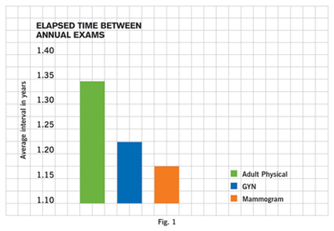
Athenaheath based its totals for adult physicals on over 200,000 such exams performed in practices within its database. Its average for GYN exams is based on over 380,00 such exams, and its figure for mammograms is based on more than 75,000 such exams for women over age 40.
This means the average practice could yield 20 percent to 34 percent additional revenue from these services if it proactively scheduled patients to receive annual care.
Take a look at how two real practices perform when you break down the adult annual physicals they provide by days since the last physical. (See Fig. 2.) The proactive practice maximizes its patients’ periodic exams by clustering them at or close to the one-year mark. The reactive practice allows the time between “annual” visits to lapse into a second or even a third year.
To fall in line with proactive health maintenance, set up the following policies at your practice:
- Identify important health maintenance events for your patient base (i.e., mammography, adult physicals, diabetes checkups, GYN exams, etc.).
- Identify patients who have not come in for such health maintenance events, and proactively move to schedule appointments for them.
- Check patients who have had diagnoses result from routine exams, and evaluate whether they are seen frequently enough.
- Educate patients on the importance of complying with their recommended health maintenance schedule.
- Establish policies and automated procedures for creating appointment reminders for your patients.
The actual process of scheduling with a patient presents a golden opportunity to accomplish several tasks that can improve your practice’s performance. Through effective scheduling, you can keep your daily schedule full, improve patient satisfaction, and make sure your patients come prepared for their visits. To get the most from those scheduling conversations:
- When scheduling with a patient, always suggest the earliest available slot, and offer same-day appointments whenever possible.
- Always check for future appointments that can be moved up or combined with another appointment.
- Remind patients of outstanding balances, and collect those balances by credit card over the phone if possible.
- Send any required forms to patients prior to their appointments whenever possible.
- Ensure that patients know what they need to do to prepare for their visits (fast for labs, complete forms, obtain referrals, etc.).
- Inform patients of any services they are likely to receive that are not covered by their insurance.
- Ask patients to arrive 5 to 10 minutes prior to their appointment times.
- Verify patient demographic/insurance information.
Handling no-shows
No-shows can be a sensitive question for practices because they are sometimes related to socioeconomic issues (unpredictable work schedules, inability to miss work, transportation problems, etc.). Some practices compensate by overbooking. Others justify no-shows as a lesser evil. After all, a couple of no-shows on one day mean the physician can spend a few more minutes with another patient, everyone’s wait time will be less that day, or there will be room to fit in that walk-in. What’s the real harm?
If that rationale sounds OK to you, it’s time to check your reactive meter. No-shows are the ultimate poster child for poor preventive management because once a no-show occurs, there’s no getting it back. A no-show is lost revenue — time that could and should have been scheduled and spent with a patient who now will not be seen that day. (See Fig. 3.)
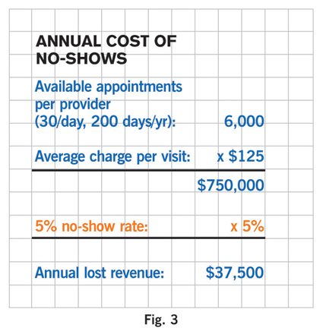
So what can you do to minimize no-shows? Develop a policy that matches the needs of your patient population. Only you can determine how to best strike the delicate balance between instilling patient discipline and maintaining satisfaction given your patient panel’s socioeconomic status, access to transportation, etc. That said, here are a few general recommendations:
- Institute a no-show fee policy, communicate it frequently, and enforce it consistently.
- Adopt a “three strikes and you’re out” policy. After three no-shows within a 12-month period, restrict the patient to same-day-only appointments for six months.
- Consider eliminating chronic offenders from your patient panel.
Finally, you must examine your own behavior as a practice if you want to influence the way your patients act. Anecdotal evidence suggests provider behavior affects patient behavior. If your patients regularly face office cancellations or long waits, they are more likely not to show up or to arrive late.
Looking at the check-in/check-out times for patients at 398 practices in March 2006 recorded in the athenaNet database, we found that patients were in their doctors’ offices an average of 3.6 times longer than their scheduled appointment times. (See Fig. 4.)
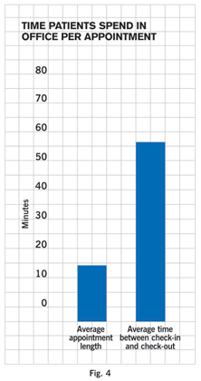
Confronted with these data, it’s easy to conclude that the best way to improve patient behavior is to shore up your own scheduling efficiency. In other words, enhance your scheduling practices, and your patients will be more likely to comply with your procedures.
Kevin Tolin-Scheper is a clinical engagement manager at athenahealth, a revenue and clinical cycle management company for medical practices whose database of billing information is the statistical basis for this series. Tolin-Scheper can be reached via editor@physicianspractice.com. Check out www.athenahealth.com/diagnostic for more tools to assess the health of your practice.
This article originally appeared in the September 2006 issue of Physicians Practice.

